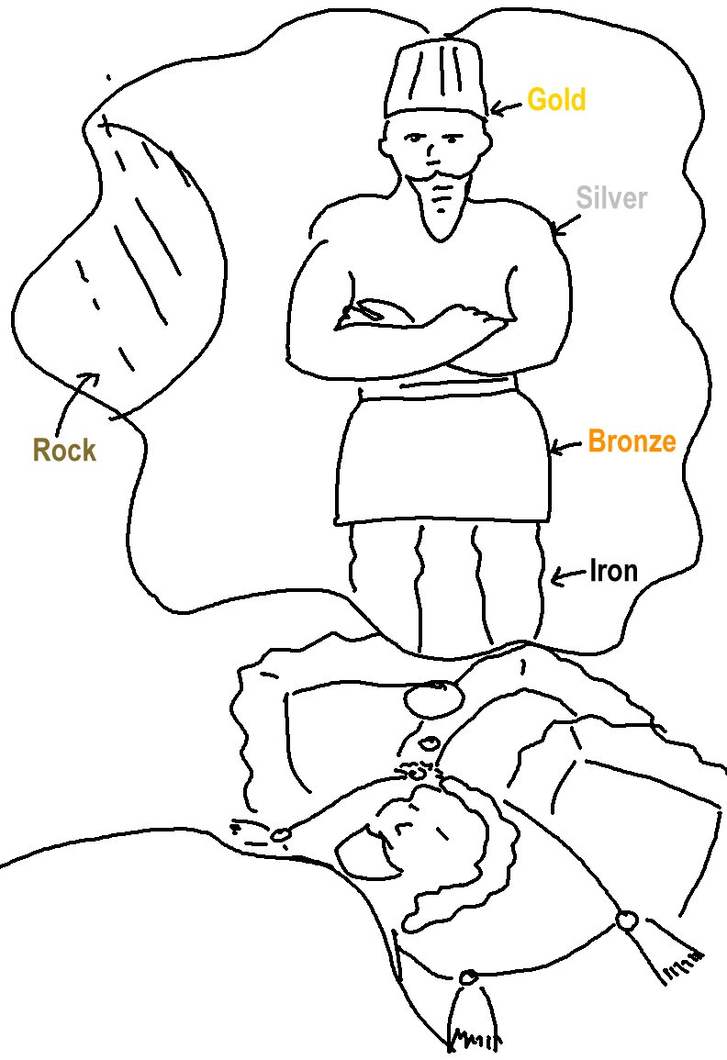

Whatever the Lord God plans to do, He tells his servants, the Prophets.
Amos 3:7_{CEV}

